

PPD Customize Tool
for Linux

Ver.1.00

Revision History

Date | Revision | Description
2013/7/31 | 1.0 | issued
目次
1. Scope 4
2. Preparation 4
3. Supported Function 5
3.1. Function Addition for Retention Function 5
3.2. Function Addition for User Name 6
3.3. Addition for Job Name/User Name/PC Name 7
3.4. Cancellation of restriction for Bypass and Paper Type 9
3.5. Function Addition for User Authentication 11
3.6. Function Addition for User Number Function 12

Scope
This documentation describes the function for PPD customize tool. The tool enables to edit the PScript
which is described on PPD file.

- Support Models
(CR Series)
Pastel / C-Jupiter / C-Dragon / Venus50 / Pastel Light
Pastel2 / C-Jupiter2 / C-Frontier / Pastel2Light / C-Frontier Printer
(Jupiter Series)
Jupiter
(Hercules Series)
Hercules
(CR3 Series)
Gemini (Plus) / Aries / Virgo / Capricorn / Gemini2 (Plus) / Aries2
(Jupiter3 Series)
Jupiter3 / B-Frontier / B-Frontier Printer / Dragon3 / Jupiter3 Light
Jupiter3 Lotus / B-Frontier Scan Pro / B-Frontier2 / B-Frontier2 Printer

- Support OS
(Linux)
CUPS 1.2

Preparation
- Prepare the PC PPD file on PC.
- Prepare the tool on PC.
- Run the Terminal
- Compile the PPD.c which is included the tool by Gcc, and create PPDLinux.exe
Because how to compile is depend on the Distribution, follow a guideline of each Distribution. In almost all case, you can get the guideline from Web.
- Refer chapter.3 and enter the command according to the rules.
- Customized printer is reflected on Linux OS when created PPD file by Step1 – 5 is registered by printer registration function of OS.

Supported Function

Function Addition for Retention Function
You can add the Retention function by following step.
- Run the terminal, input the command on the terminal according to the following rule and run the command (press Enter or Return button).
Note: The path of each file is different depend on environment, so need to enter the path suited your environment.

PPDLinux.exe_ [PPD File Name]_ [PPD File Name after customization]_ [Setting File Name]_ [Password]
* ”_” (under bar) means “ ” (space).

[Password]
It is Password to be set to the PPD file.

[Execute File]
Specify the PPDLinux.exe.

[PPD File Name]
PPD file name is different depend on the model to customization.
Specify the PPD of target model name.

[PPD File Name after customization]
It must not be same name as above PPD File.

[Setting File Name]
It is the definition file of the setting included in this tool. Specify the definition file depend on each model.
CR Series “Para011.dat”
Hercules Series “Para011.dat”
Jupiter Series “Para012.dat”
CR3 Series “Para011.dat”
Jupiter3 Series “Para011.dat”

Example) Set “12345” for Password in MX-2300G
PPDLinux.exe Sharp-MX-2300G-ps.ppd Sharp-MX-2300G-ps.ppd.new Para011.dat 12345

Function Addition for User Name
You can embed User Name which is not set on UI of PPD by following step.
However, it is not possible to change the "user name" in each print.
- Run the terminal, input the command on the terminal according to the following rule and run the command (press Enter or Return button).
Note: The path of each file is different depend on environment, so need to enter the path suited your environment.

PPDLinux.exe_/R_ [PPD File Name]_ [PPD File Name after customization]_ [Setting File Name]_ [User Name]
* ”_” (under bar) means “ ” (space).

[Execute File]
Specify the PPDLinux.exe and specify “R” (upper case) as an argument.

[PPD File Name]
PPD file name is different depend on the model to customization.
Specify the PPD of target model name.

[PPD File Name after customization]
It must not be same name as above PPD File.

[Setting File Name]
It is the definition file of the setting included in this tool. Specify the definition file depend on each model.
CR Series Not supported
Hercules Series “Para023.dat”
Jupiter Series Not supported
CR3 Series “Para023.dat”
Jupiter3 Series “Para023.dat”

[User Name]
It is User Name to be set to the PPD file.

Example) Set “Admin” for User Name in MX-4500FN
PPDLinux.exe /R Sharp-MX-4500-ps.ppd Sharp-MX-4500-ps.ppd.new Para23.dat Admin

Addition for Job Name/User Name/PC Name
You can embed Job Name/User Name/PC Name which are not set on UI of PPD by following step.
However, it is not possible to change Job Name/User Name/PC in each print.
- Run the terminal, input the command on the terminal according to the following rule and run the command (press Enter or Return button).
Note: The path of each file is different depend on environment, so need to enter the path suited your environment.

PPDLinux.exe_/R_ [PPD File Name]_ [PPD File Name after customization]_ [Setting File Name]_ [User Name]_ [PC Name]_[Job Name]
* ”_” (under bar) means “ ” (space).

[Execute File]
Specify the PPDLinux.exe and specify “R” (upper case) as an argument.
[PPD File Name]
PPD file name is different depend on the model to customization.
Specify the PPD of target model name.
[PPD File Name after customization]
It must not be same name as above PPD File.
[Setting File Name]
It is the definition file of the setting included in this tool. Specify the definition file depend on each model.
- CR Series “Para022.dat”
- Hercules Series “Para022.dat”
- Jupiter Series Not supported
- CR3 Series “Para022.dat”
- Jupiter3 Series “Para022.dat”
[User Name]
It is User Name to be set to the PPD file.
[PC Name]
It is PC Name to be set to the PPD file.
[Job]
It is Job Name to be set to the PPD file.

Example) Set “Admin” for User Name, ”PC001” for PC Name and ”Test” for Job Name in MX-4500FN
PPDLinux.exe /R Sharp-MX-4500-ps.ppd Sharp-MX-4500-ps.ppd.new Para21.dat Admin PC001 Test

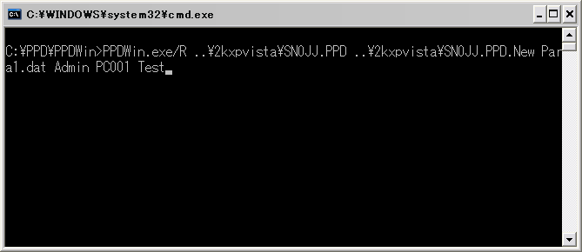
(This scree is Windows UI, so the screen will not be the same.)

Cancellation of restriction for Bypass and Paper Type
You can select the some Paper Type when selected Bypass tray following step.
In addition, regarding this cancellation on restriction, it is supposed that user takes responsibility.
- Run the terminal, input the command on the terminal according to the following rule and run the command (press Enter or Return button).
Note: The path of each file is different depend on environment, so need to enter the path suited your environment.

PPDLinux.exe_/R_ [PPD File Name]_ [PPD File Name after customization]_ [Setting File Name]
* ”_” (under bar) means “ ” (space).

[Execute File]
Specify the PPDLinux.exe and specify “R” (upper case) as an argument.
[PPD File Name]
PPD file name is different depend on the model to customization.
Specify the PPD of target model name.
[PPD File Name after customization]
It must not be same name as above PPD File.
[Setting File Name]
It is the definition file of the setting included in this tool. Specify the definition file depend on each model.
- CR Series “Para031.dat”
- Hercules Series Not supported
- Jupiter Series “Para031.dat”
- CR3 Series “Para031.dat”
- Jupiter3 Series “Para031.dat”

Example) Cancell the restriction for in MX-4500FN
PPDLinux.exe /R Sharp-MX-4500-ps.ppd Sharp-MX-4500-ps.ppd.new Para31.dat

- Creation completion of PPD
If “Output:” is displayed, process is finished without any problem.
If process is not finished without any problem, ”[ERROR]” is displayed.
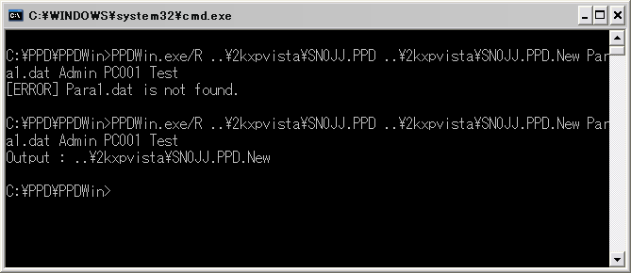
(This scree is Windows UI, so the screen will not be the same.)

- Creation completion of PPD
Change the name of the PPD file which is created on Step2 to the original name of the PPD file. Then, copy the file to the folder of the driver which you are installing, and install it.

Example) Rename ”Sharp-MX-4500-ps.ppd.new” of created PPD file to “Sharp-MX-4500-ps.ppd”.

Notes)
If you would like to set other information, you must prepare the PPD file which doesn’t perform the Step3. Information is not set if you run the tool for the PPD file which perform the Step 3.

Function Addition for User Authentication
You can add the User Authentication function by following step.
  - Run the terminal, input the command on the terminal according to the following rule and run the command (press Enter or Return button).
Note: The path of each file is different depend on environment, so need to enter the path suited your environment.

PPDLinux.exe_/R_ [PPD File Name]_ [PPD File Name after customization]_ [Setting File Name]_ [Login Name]_ [Login Password]
* ”_” (under bar) means “ ” (space).

[Execute File]
Specify the PPDLinux.exe and specify “R” (upper case) as an argument.

[PPD File Name]
PPD file name is different depend on the model to customization.
Specify the PPD of target model name.

[PPD File Name after customization]
It must not be same name as above PPD File.

[Setting File Name]
It is the definition file of the setting included in this tool. Specify the definition file depend on each model.
- CR Series “Para052.dat”
- Hercules Series “Para052.dat”
- Jupiter Series Not supported
- CR3 Series “Para052.dat”
- Jupiter3 Series “Para052.dat”

[Login Name]
It is Login Name to be set to the PPD file.
[Login Password]
It is Login Password to be set to the PPD file.

Example) Set ”Sharp” for Login Name and set “12345” for User Number in MX-2300G
PPDLinux.exe /R Sharp-MX-2300G-ps.ppd Sharp-MX-2300G-ps.ppd.new Para052.dat Sharp 12345

Function Addition for User Number Function
You can add the User Number function by following step.
- Run the terminal, input the command on the terminal according to the following rule and run the command (press Enter or Return button).
Note: The path of each file is different depend on environment, so need to enter the path suited your environment.

PPDLinux.exe_/R_ [PPD File Name]_ [PPD File Name after customization]_ [Setting File Name]_ [User Number]
* ”_” (under bar) means “ ” (space).

[Execute File]
Specify the PPDLinux.exe and specify “R” (upper case) as an argument.

[PPD File Name]
PPD file name is different depend on the model to customization.
Specify the PPD of target model name.

[PPD File Name after customization]
It must not be same name as above PPD File.

[Setting File Name]
It is the definition file of the setting included in this tool. Specify the definition file depend on each model.
- CR Series “Para053.dat”
- Hercules Series “Para053.dat”
- Jupiter Series Not supported
- CR3 Series “Para053.dat”
- Jupiter3 Series “Para053.dat”

[User Number]
It is User Number to be set to the PPD file.

Example) Set “12345” for User Number in MX-2300G
PPDLinux.exe /R Sharp-MX-2300G-ps.ppd Sharp-MX-2300G-ps.ppd.new Para053.dat 12345

